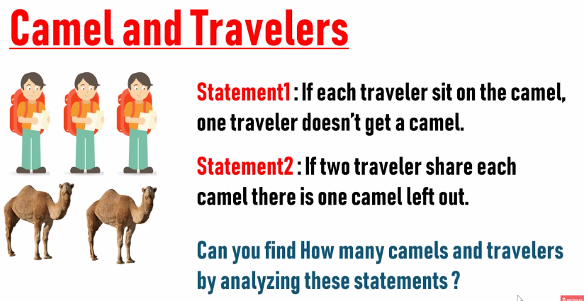

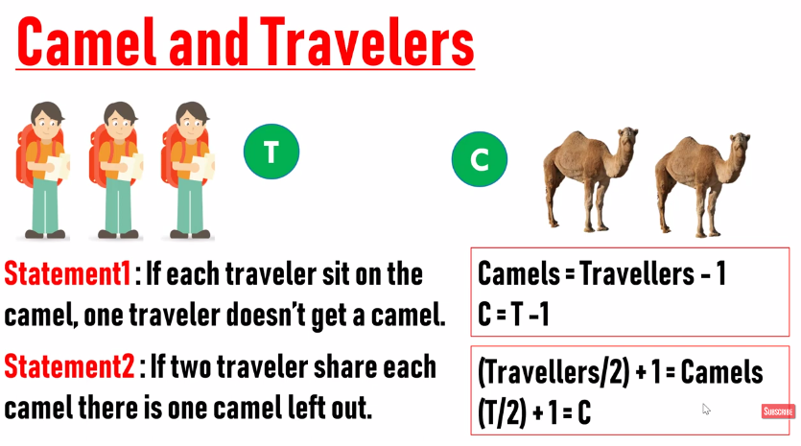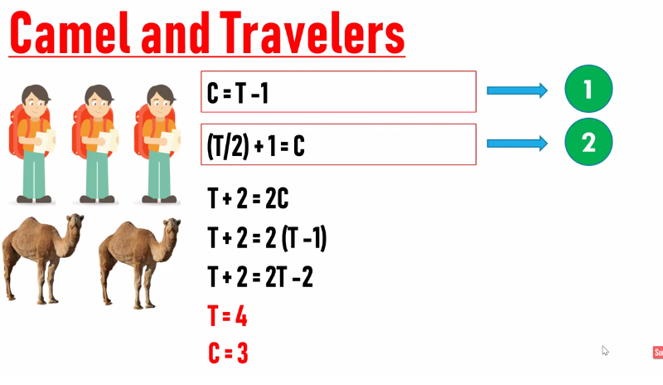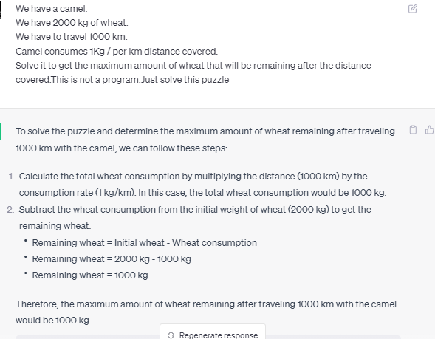

**https://www.youtube.com/watch?v=cfd2TxmibSU&list=PLhm1_7YKigpfPXD0QaY4tWZeCpkkiSWxR&index=16**

# Unit Gold Rod Puzzle

# The Tower of Hanoi

# 

# Measure 15 min from 7 & 11 min sand clock, sand timer puzzle,

[**https://www.youtube.com/watch?v=9qlmpoEl8-8**](https://www.youtube.com/watch?v=9qlmpoEl8-8)

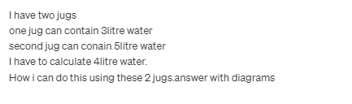

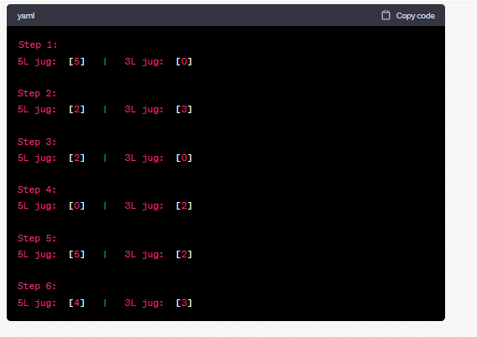

**Question :**

**You are given a cake, you need to divide the cake into 8 pieces into 3 attempts. How you will do this?**

[**https://www.youtube.com/watch?v=j6oQvWBubPg**](https://www.youtube.com/watch?v=j6oQvWBubPg)

**Question**

**Two trains are moving towards each other with a speed of 80KM/h.**

**There is a distance of 180km between them. There is a bird on the front side of first train**

**which move towards second train and return back**

**when the bird reached the front of the second train. The bird speed is 70km/h.**

**What will be the total distance covered by the bird when both trains will collide.**

**Answer;**

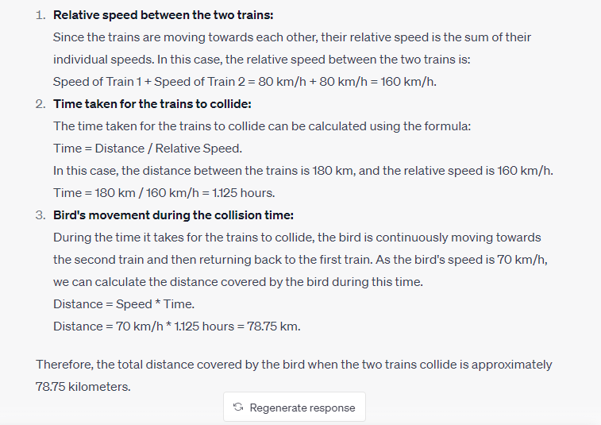

**Question There are 9 snooker balls, each of the same size and the same weight except for the one, it's heavier than others. you have a sea-saw to weigh them. tell the minimum number of times you'd use the sea-saw to find the heavier one. also explain your logic.**

**To find the heavier snooker ball among 9 balls using a sea-saw, the minimum number of times you would need to use it is 2.**

**Answer:**

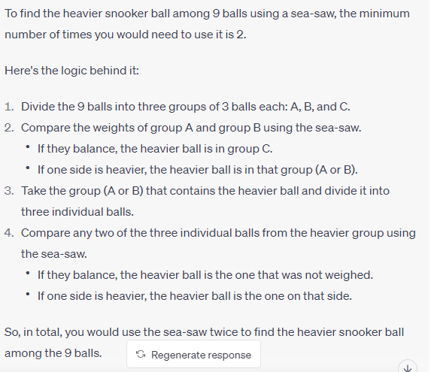

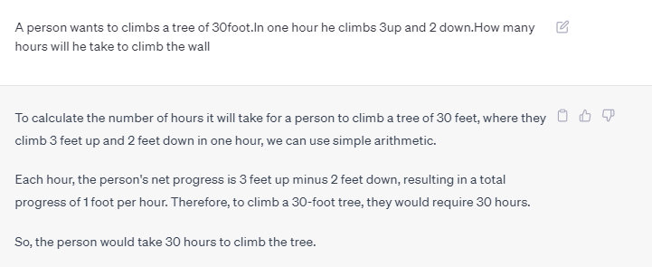

# Three Mislabeled Jars Puzzle

# 

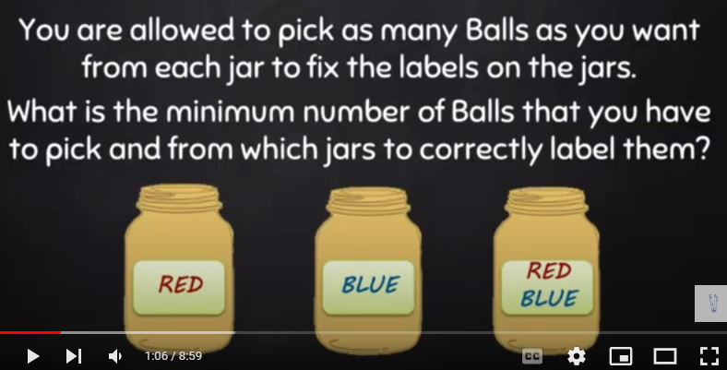

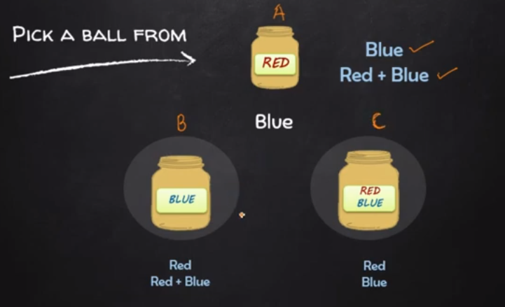

<https://www.youtube.com/watch?v=-S2eGQf9QvQ&list=PLhm1_7YKigpfPXD0QaY4tWZeCpkkiSWxR&index=2&pp=iAQB>

# Ant and Triangle Problem | Interview Puzzle

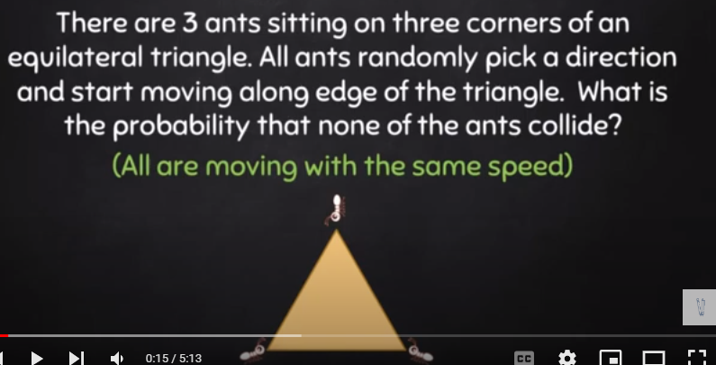https://www.youtube.com/watch?v=I_mW_AMWDK8&list=PLhm1_7YKigpfPXD0QaY4tWZeCpkkiSWxR&index=3

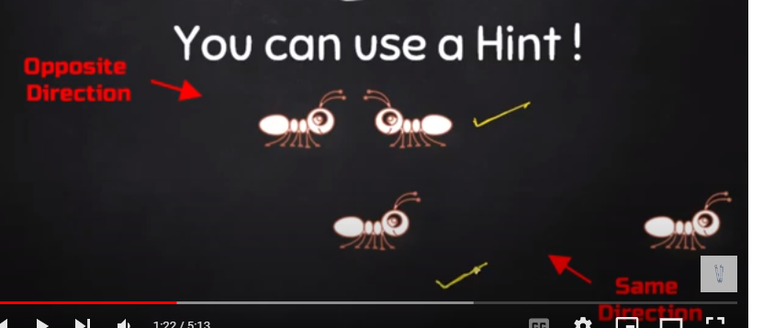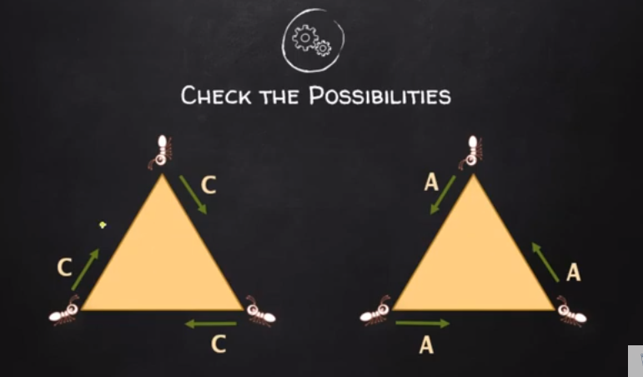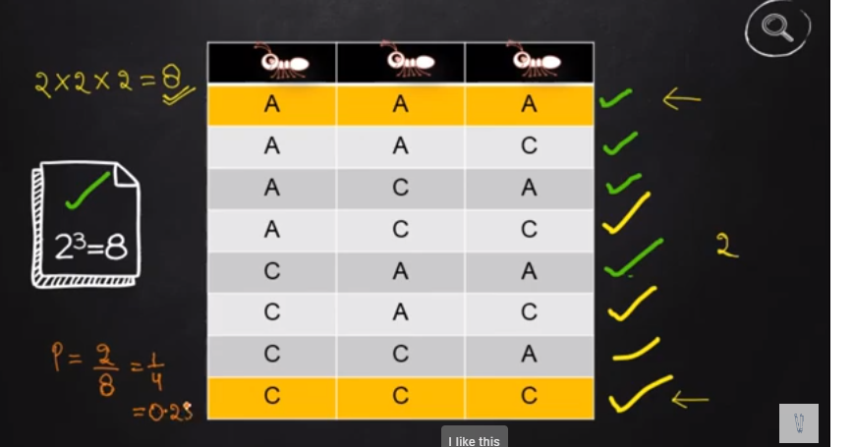

Ab hr ant ka pas 2 possibilities hain ka either wo left jay ya right jay yani 2 directions hi.Ab 2 possibilities for ant1*2possibilities for ant2*2possibilities for ant3=8

Possibilities/total outcomes=Probability of not colliding.Yani agr hum tenon ants ko same direction ma move kraain either anticlockwise or clockwise then they will not collide.Ab humny probability find krni tu

Total favorable outcomes/total possibilities=2/8=

clockwise jana ya sbka anticlockwise jana=sari possibilities



# POISON AND RATS | Google Interview Puzzle

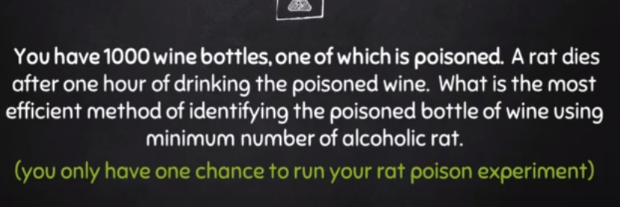https://www.youtube.com/watch?v=U7mmBUPcNuY&list=PLhm1_7YKigpfPXD0QaY4tWZeCpkkiSWxR&index=4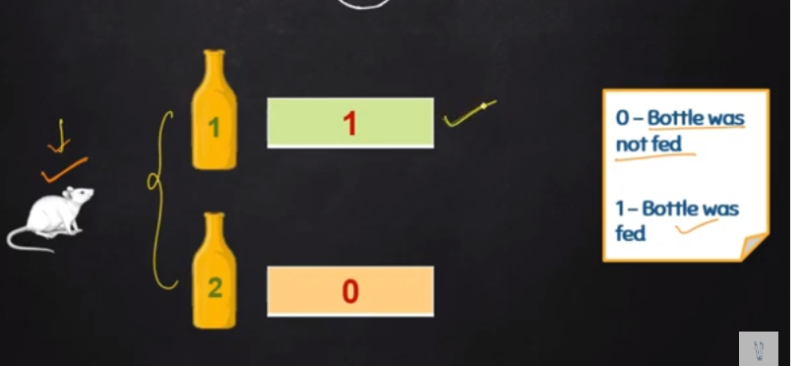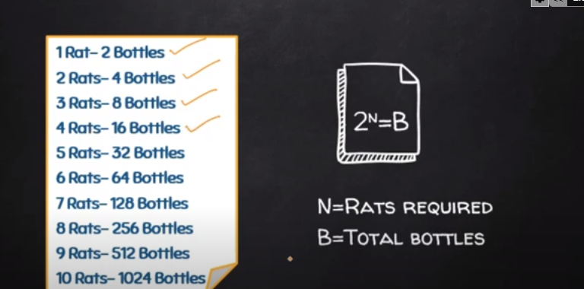

**Heaven Hell Puzzle**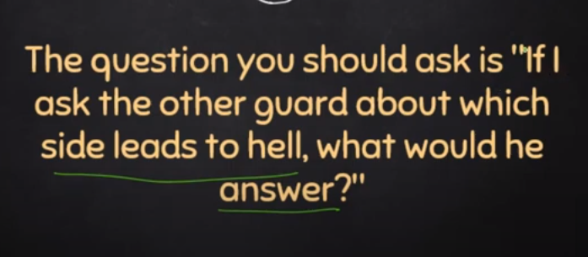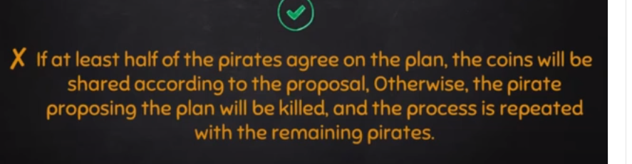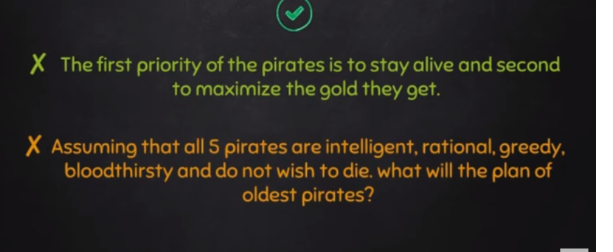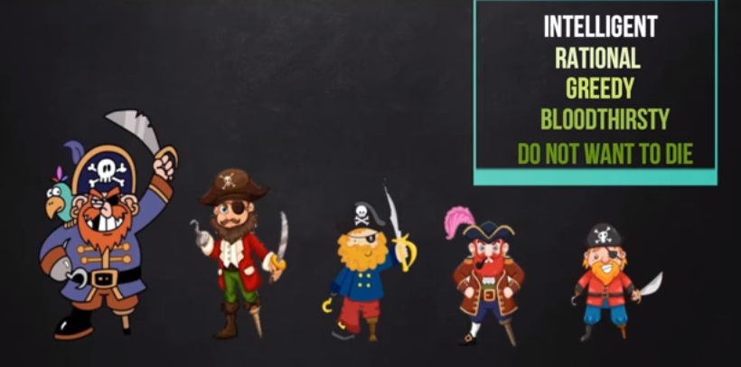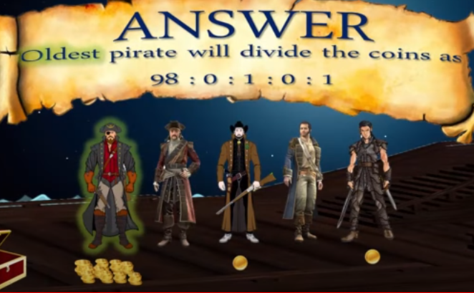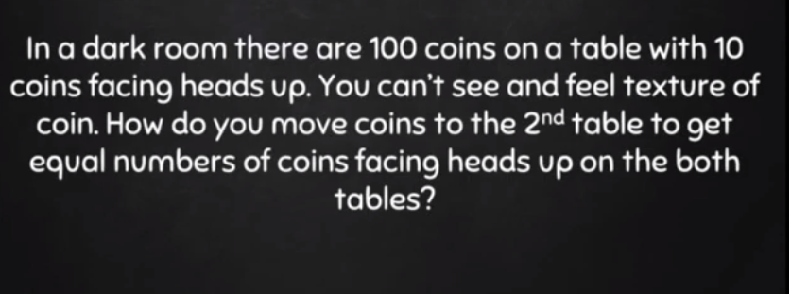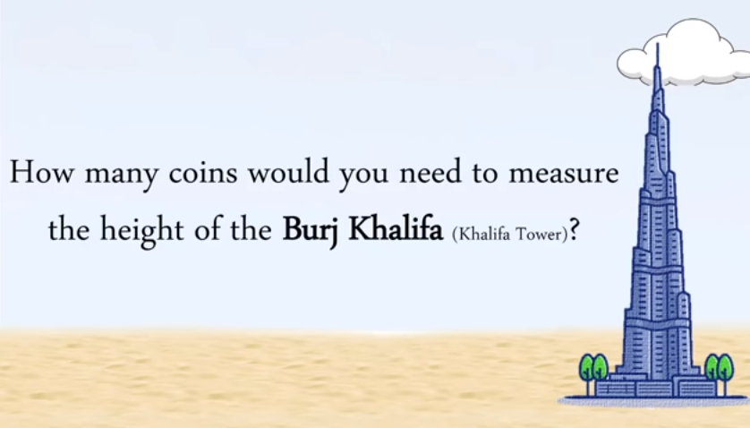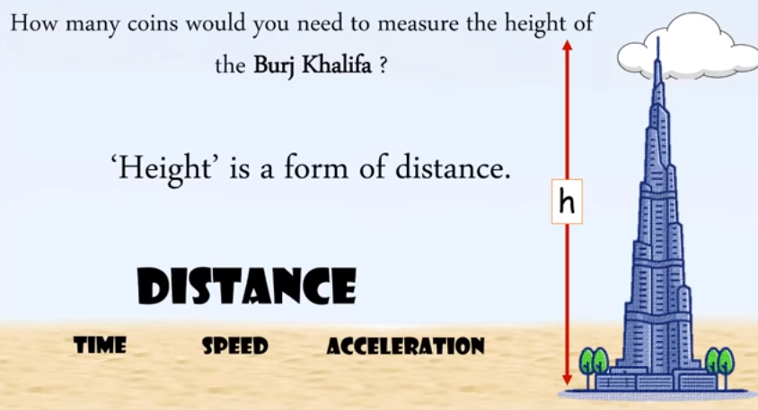

<https://www.youtube.com/watch?v=SrqzNdkn74Q&t=110s>

# 5 Hats Puzzle | Interview Puzzle

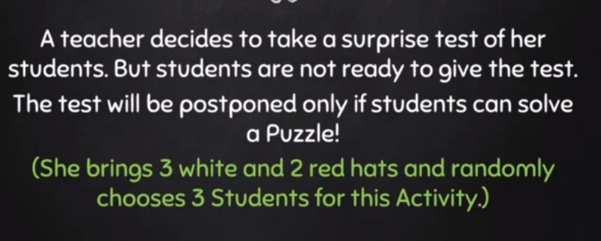

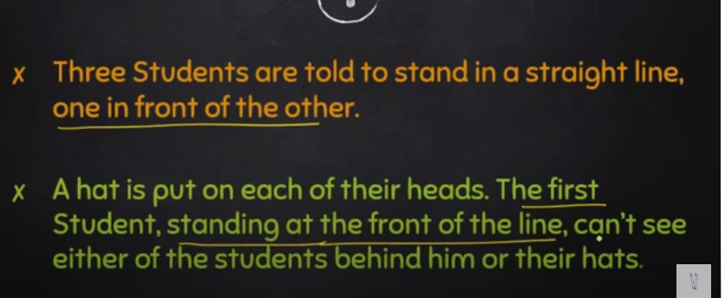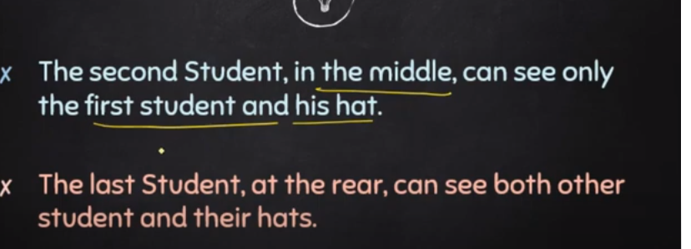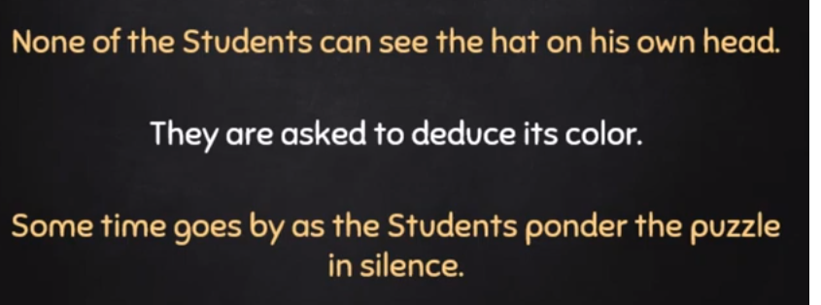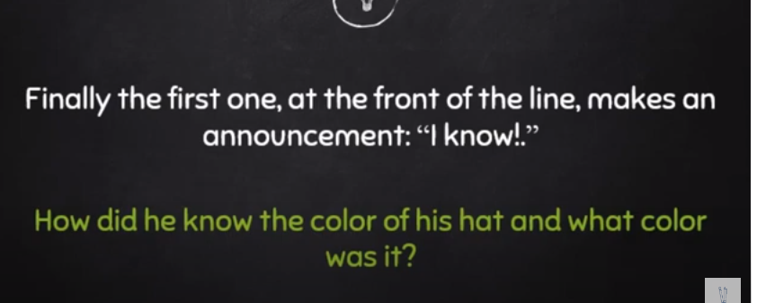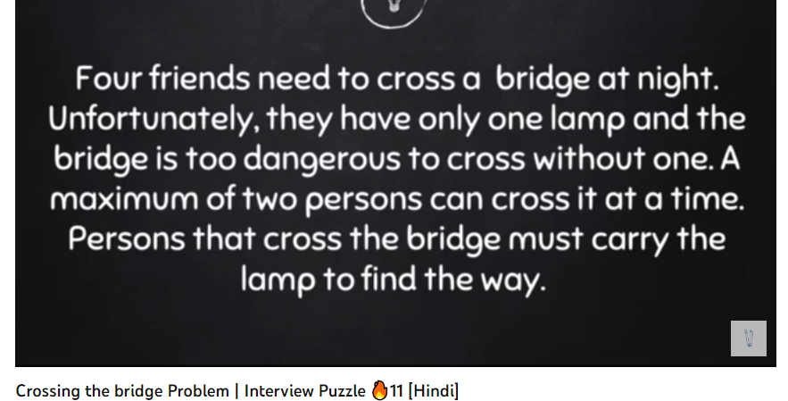

# Burning Rope Problem

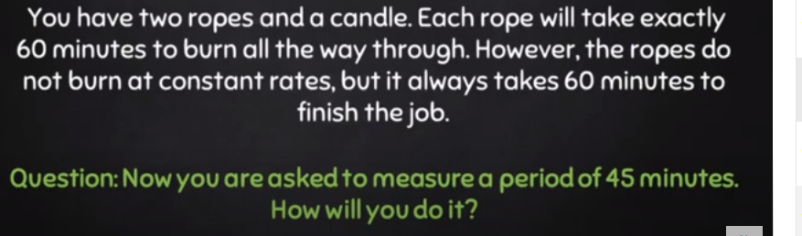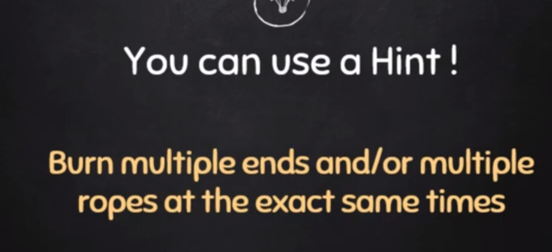

# Chain links Problem |



<https://www.youtube.com/watch?v=Ozs9E0-7DF4>

# Defective Gold Coins Problem | Interview Puzzle

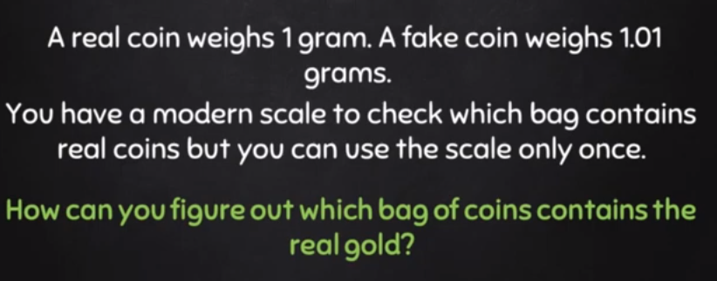

Just take the difference between Total-Current

# Car Wheels Problem | Interview Puzzle

